**Maven lifecycle:**

3 life cycles

1. Default
2. Clean
3. Site

Default life cycle is important



**Build phases of default life cycle:**

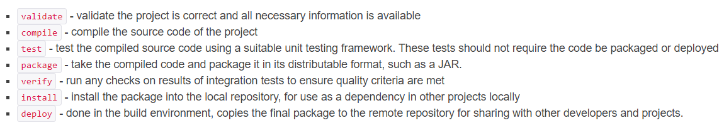



* These are the 7 important phases of default life cycle

**Maven Goal:**

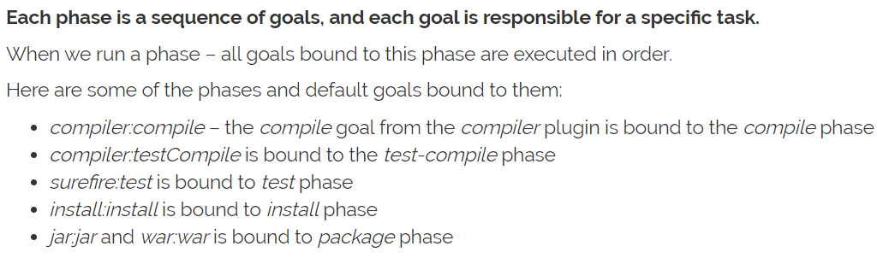

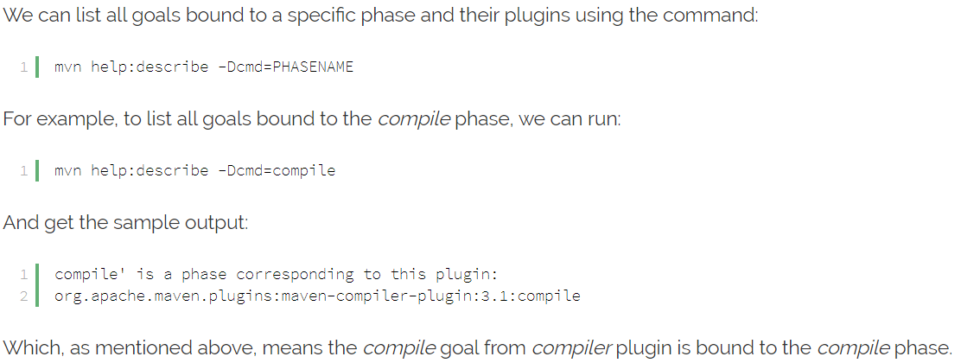

When we build the code, the compiled classes and the artefact gets stored in target folder inside the project

**Clean life cycle:**

* The clean command used to delete the target folder. Used to clean up the directory
* **Mvn clean**
* By using the below command, we can clean, create package and execute it
* **Mvn clean package exec:java**

**Site life cycle:**

* Nobody uses it, it used for only creation of documents
* By running the below command, it just creates a documentation for our source code in target folder
* **Mvn site**
* It creates html files. It contains all the info about project